Technical Design for Presentation Manager

Revision History

Issue | Date | Person | Reason
0.1 | March 7, 2002 | Darryl Long | Created
1.0 | April 12, 2002 | Darryl Long | Reviewed by team and released

Description

Introduction
The Presentation Manager provides an interface to other parts of the game to handle the cinematic elements in the game including NISes, transitions, camera animations and movies.

Playing movies is going to be a problem. We learned from the last game that the movie player fragment memory really badly on the PS2 and GameCube (we didn’t seem to have the same problem on the X-Box).

A further problem is memory usage, ignoring fragmentation. The PS2 movie player took at least 3 to 5 MB of RAM and we obviously won’t have nearly enough room for that. Unloading game data for playing a movie is not possible, thus we have dropped in-game movies in favour of NISes.

Movies are played at the beginning and end of each Level, while short NISes are played at the beginning of each mission. There is no NIS at the end of a mission, only a short animation and some dialog representative of success of failure.

NISes are much more lightweight. Estimates from Nigel Brooke are as follows:

“The worst case is about 28 bytes, per character, per joint, per frame. If you've got, say 3 50 joint characters, that works out to about 126k per second of NIS. However, that is the WORST case there. It assumes that you are using uncompressed quaternions, that every joint has translation (most don't) and that you have a keyframe at every frame (usually not true, particularly for NISs where sometime stuff won't be moving, which is rare for in game character animations.

“Average case, I'd guess probably less than half of that, maybe as little as a third.”

Requirements

- Play movies at beginning and end of each level
- Play NISes at the beginning and end of each mission
- Play camera animations (as a subset of NIS)
- Perform screen transition effects
- Watch for events that indicate the start of a presentation segment
- Demo sequence exceeding 1 minute
- Play Simpsons music during scene transitions
- Display a mission title at beginning of mission
- Manage countdown to mission start (some screen anim and/or sound)
- Manage end of mission procedural finish
- Show text at end of mission (e.g. You failed!)
- Play sounds at the end of the mission (and music?)
- Control the camera procedurally to frame a conversation

References

- Talked to Vlad
- Talked to Joe McGinn
- Talked to Darren about movie player
- Nigel Booke about NISes
- Wilfred about movies
- Held meetings with Designers and Artists

Technical Design

Relationships
Lots of other components in the game will use the Presentation Manager to make stuff happen. At the beginning of the game (and from some menu) the Presentation Manager will play a movie. Between missions the PM will play NISes, and during gameplay the PM is triggered by an to insert an NIS into the world.

Some components will ask the Presentation Manager to fade the screen to or from black to provide a smooth transition between scenes. The PM will also support wipes, where one scene is incrementally drawn occupying screen space until it occupies the whole screen. Finally, the PM has a “cross fade” or “dissolve” effect which incrementally blends between two scenes.

The PM tells the Sound System to play music files and sound effects.

The PM needs to control the car to have it skip to a stop at the end of a mission.

The PM interfaces with the camera system for procedural camera movement such as framing a pair of characters or zooming in on a conversation. Must set the point of interest, distance and angles.

The PM uses RenderWatchers from the RenderManager to control transition effects such as fades and wipes. It has several such RenderManager subclasses, one for each transition or perhaps a single one with internal state for handling multiple types of transitions.

The PM talks to the GUI to make bitmaps and text messages appear on screen. Examples of this are the message at the beginning and end of a mission and the countdown before a mission starts.

Interface

enum TransitionEnum
{
TRANS_FADETOBLACK,
TRANS_FADEFROMBLACK,
TRANS_WIPELEFT,
TRANS_WIPERIGHT,
TRANS_DISSOLVE,
NUM_TRANSITIONS
};

class MoviePlayer
{
public:
void Load( char* filename );
void Play();
void Dump();
};

class NISPlayer
{
public:
void SetNIS( tSceneGraph* nis );
void Play();
void SetIntro( Transition trans );
void SetOutro( Transition trans );
};

struct Transition
{
TransitionEnum transtype;
unsigned int length;
};

struct NISInfo
{
tSceneGraph* sceneGraph;
tMultiController* masterController;
Transition intro;
Transition outro;
SoundStream* soundStream;
CALLBACK* queued;
CALLBACK* complete;
};

class PresentationManager : public Manager
{
public:
void QueueNIS( NISInfo nisInfo, unsigned int index& );
void PlayNIS( unsigned int index );
void DumpNIS( unsigned int index );

void PlayMovie( char* filename );

void Transition( Transition transition, LevelEnum oldLevel, LevelEnum newLevel );
void Update( unsigned int elapsedTime );
protected:
void DisplayText( unsigned int textIndex );
void PlayMusic( ? );
void PlaySound( ? );
private:
enum PresentationState
{
STATE_NONE,
STATE_MOVIE,
STATE_NIS,
STATE_DELAY,
STATE_TEXT,
STATE_BITMAP,
STATE_TRANSITION,
STATE_SOUND,
STATE_MUSIC
};

// maybe this should be a class so less unused data
// but then it needs to be allocated at run-time…
// how about two stacks, one for sounds and one
// for renderables?
struct PresentationData
{
TransitionState state;
unsigned int time;
unsigned int eventID;
IRenderable* renderable;
unsigned int soundID;
};

unsigned int mStackIndex;
PresentationData mStack[ MAX_PRES_SIZE ];
};

NISes are loaded as part of the level and mission data. The mission manager (or whatever loads the NIS) should queue the NIS by calling QueueNIS passing a NISInfo struct as the parameter. The caller receives an index of the NIS for quick reference when the NIS needs to be played.

Movies are played immediately after a call to PlayMovie. Movies can not be cached.

The majority of other PM features are implemented internally triggered by the receipt of events.

The Update method is used to progress presentation elements that take some time. This implies that the PM needs internal state, such as “I am doing a transition” or “I am displaying text for n seconds”.

The PM must track multiple possible actions, such as displaying text while the screen transitions from an NIS to gameplay. A simple stack (implemented as a fixed-size array) is the most reasonable implementation for this. As a new presentation element is added (such as a new bitmap), it is added to the end of the PresentationData stack. When its time has expired or its event is received the stack index is reduced by 1.

Component Class Diagrams
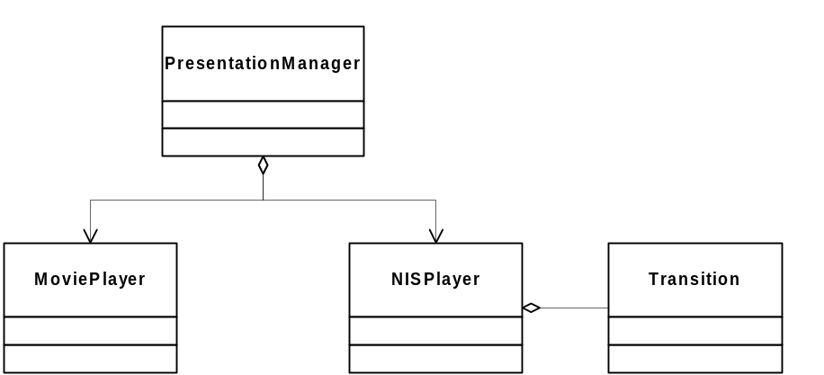

Use Cases
The loading of most NISes is handled by the Mission Manager, which then queues a request with the Load Manager. The NIS is placed in the Pure3D inventory, and a pointer to it retrieved by the Mission Manager (which has a script of NISes). When the mission is being prepared for play (Mission::Initialize), it queues all the NISes related to that mission (probably only one).

Later, when notified by a trigger volume, the Mission Manager instructs the Presentation Manager to play the NIS. When the mission is removed from memory, the Mission Manager tells the PM to dump the NIS.

In the case of a movie, the Gameplay Manager tells the movie to start using PlayMovie before it loads all the data for the level and mission.

